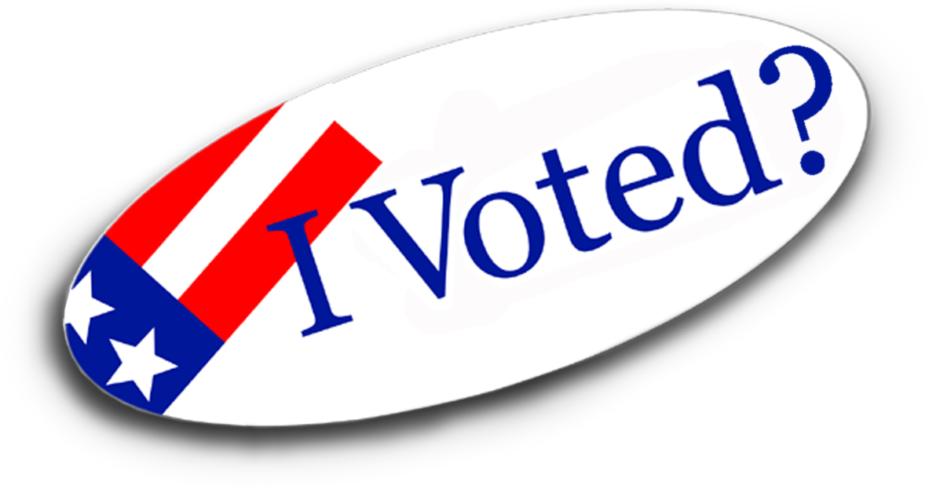
Over the last decade,
millions of votes have disappeared.
A nation can be stolen without guns or tanks.
A nation can be stolen vote by vote.
________________________________

Direct Cinema Limited presents a Concentric Media Film
STEALING AMERICA
Vote by Vote

A new feature length documentary film

.
Narrated by PETER COYOTE
Original music LAURENCE ROSENTHAL
Produced and Directed by
Oscar-nominated, Emmy-winning Filmmaker
DOROTHY FADIMAN
Date/s & Time at Venue
Address, City, State
Other Contact Info
________________________________

Compelling, meticulously accurate, poignant…
First-person stories from the election trenches paint a
chilling picture of problems affecting election outcomes,
"glitches" and "irregularities" which cannot be
explained away as random errors.

We all need to learn as much as possible
as quickly as possible about our electoral system –
before it is too late.
______________________

